Task

In not more than 200 words (+/- 10%), graphically report text graphs, sentiment analysis (i.e., Word cloud and ggplot), and analytically comment on the visualization of any built-in or open-source dataset.

Origin of dataset: Amazon

Description of the dataset: a collection of action-adventure video game reviews consisting of user info, ratings, and a plain-text review.

Purpose of Analysis: to get an insight into the opinions of action gameplay with a solving element and discover the languages used to describe their experiences.

Number of words: 22,373.

**Sentimental Analysis**

**Fig 1**

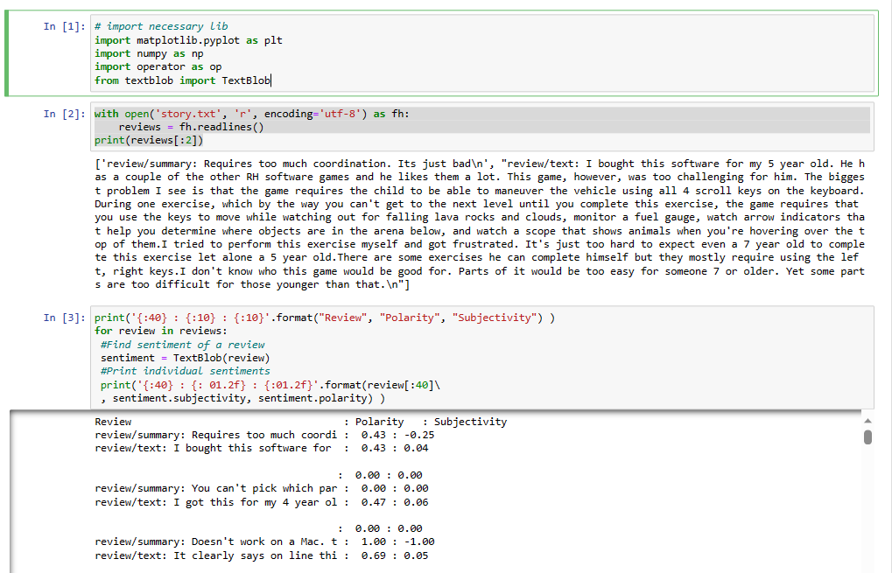

In Fig 1, I imported the necessary library for sentiment analysis. Open the dataset as a text file, “story.txt.” I printed the polarity and subjectivity scores using the text blob library, which displays the reviews in a tabular form.

**Fig 2**

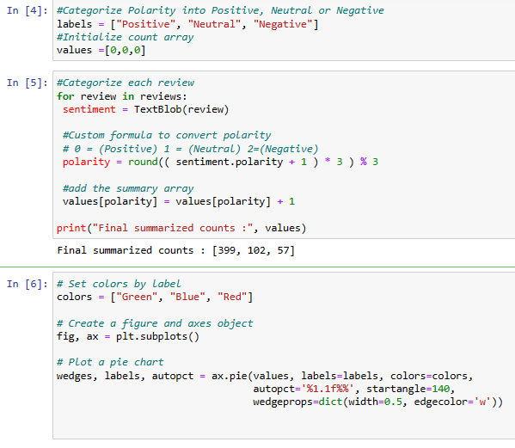 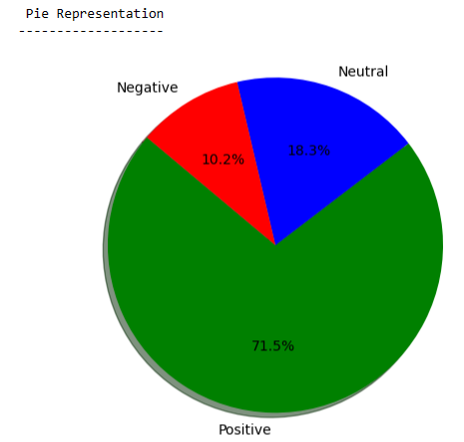

In Fig 2, I went ahead to categorize the polarity of the reviews into positive, neutral, and negative, using values as an array to keep track of the count. The count depicted 399 categories as being positive, 102 were neutral, and 57 were negative. The pie chart shows more of a positive sentiment from the review.

**Frequently Used Words**

Fig 3

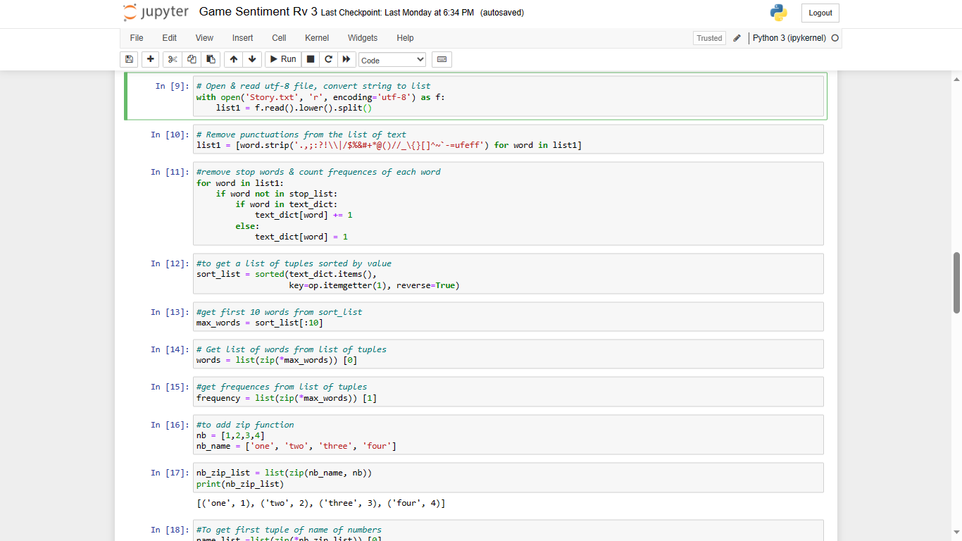

I opened an empty dictionary “text_dict”, converted my contents with a list of stop words, and removed all punctuation marks along with any unnecessary noise. I sorted them in descending value based on frequent words and arranged the first 10 words in a list. After removing the stop words and sorting the dictionary, I extracted the top 10 most frequent words.

Fig 3

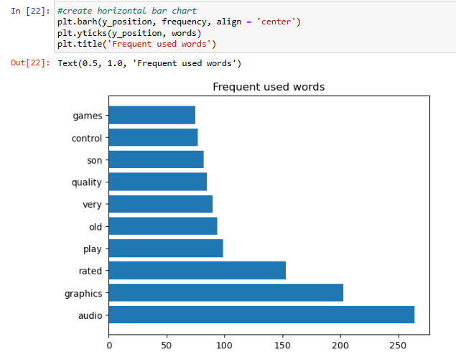

Words like quality, graphics, and audio refer to good technical and operational aspects of the videogames while the word son suggests more engagement from male children.

**Word cloud**

Fig 4

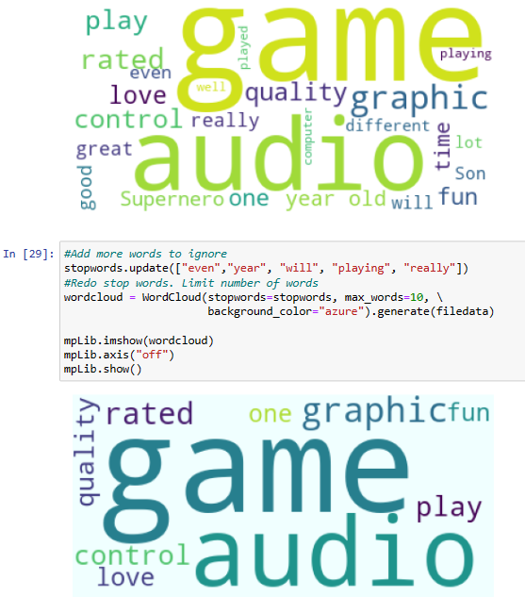

Based on my analysis, there was a mixed feeling with a majority of the reviews being positive.

* Sentimental analysis of the video game review has a positive sentiment with an overall good gameplay perception.
* Significant neutral and negative reviews leave areas for improvement.
* Rated and graphics as the most frequently used words indicate that these aspects of the game were particularly noteworthy to reviewers.
* A similar gameplay theme targeted towards male-oriented children.

**REFERNCES**

[SNAP: Web data: Amazon reviews (stanford.edu)](http://snap.stanford.edu/data/web-Amazon-links.html);

http://snap.stanford.edu/data/web-Amazon-links.html

Python: Bar Chart Word Cloud from text file, Wikipedia by Using jupyter Notebook;

https://www.youtube.com/watch?v=RdqcHAVmqEQ&t=2761s